ISLAMIC UNIVERSITY OF TECHNOLOGY

Organization of Islamic Cooperation

Board Bazar, Gazipur

User Interface Design

CSE 4513

Shohel Ahmed

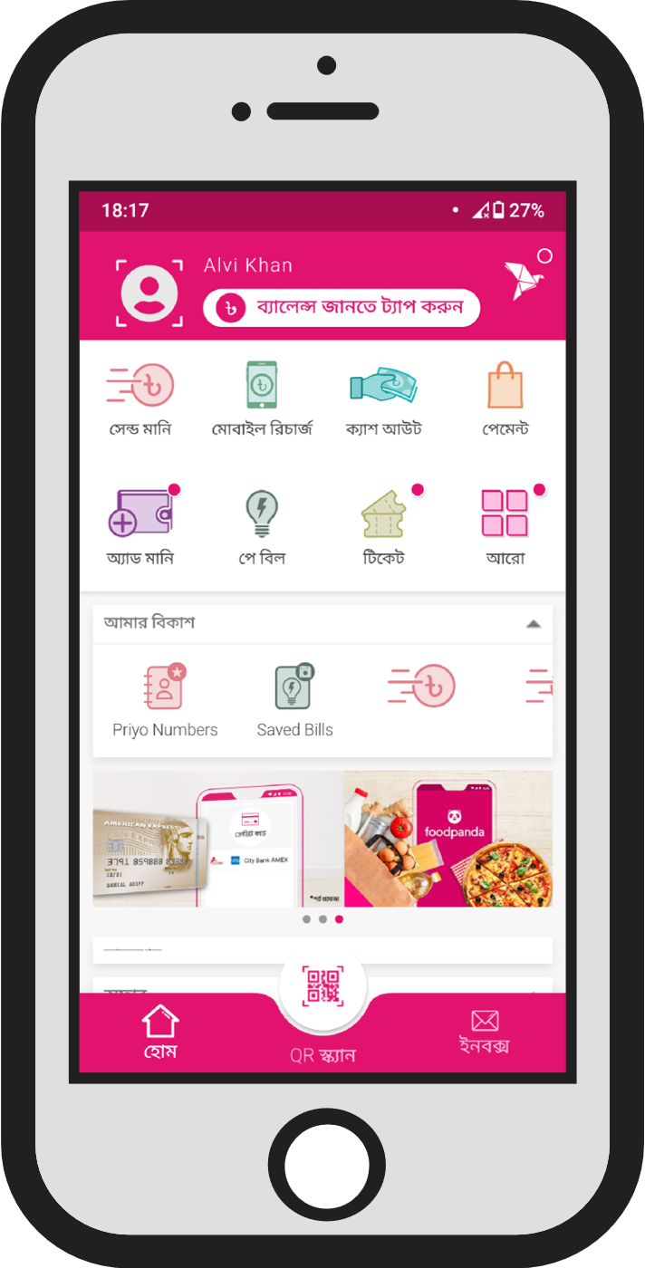

**Problematic UI**

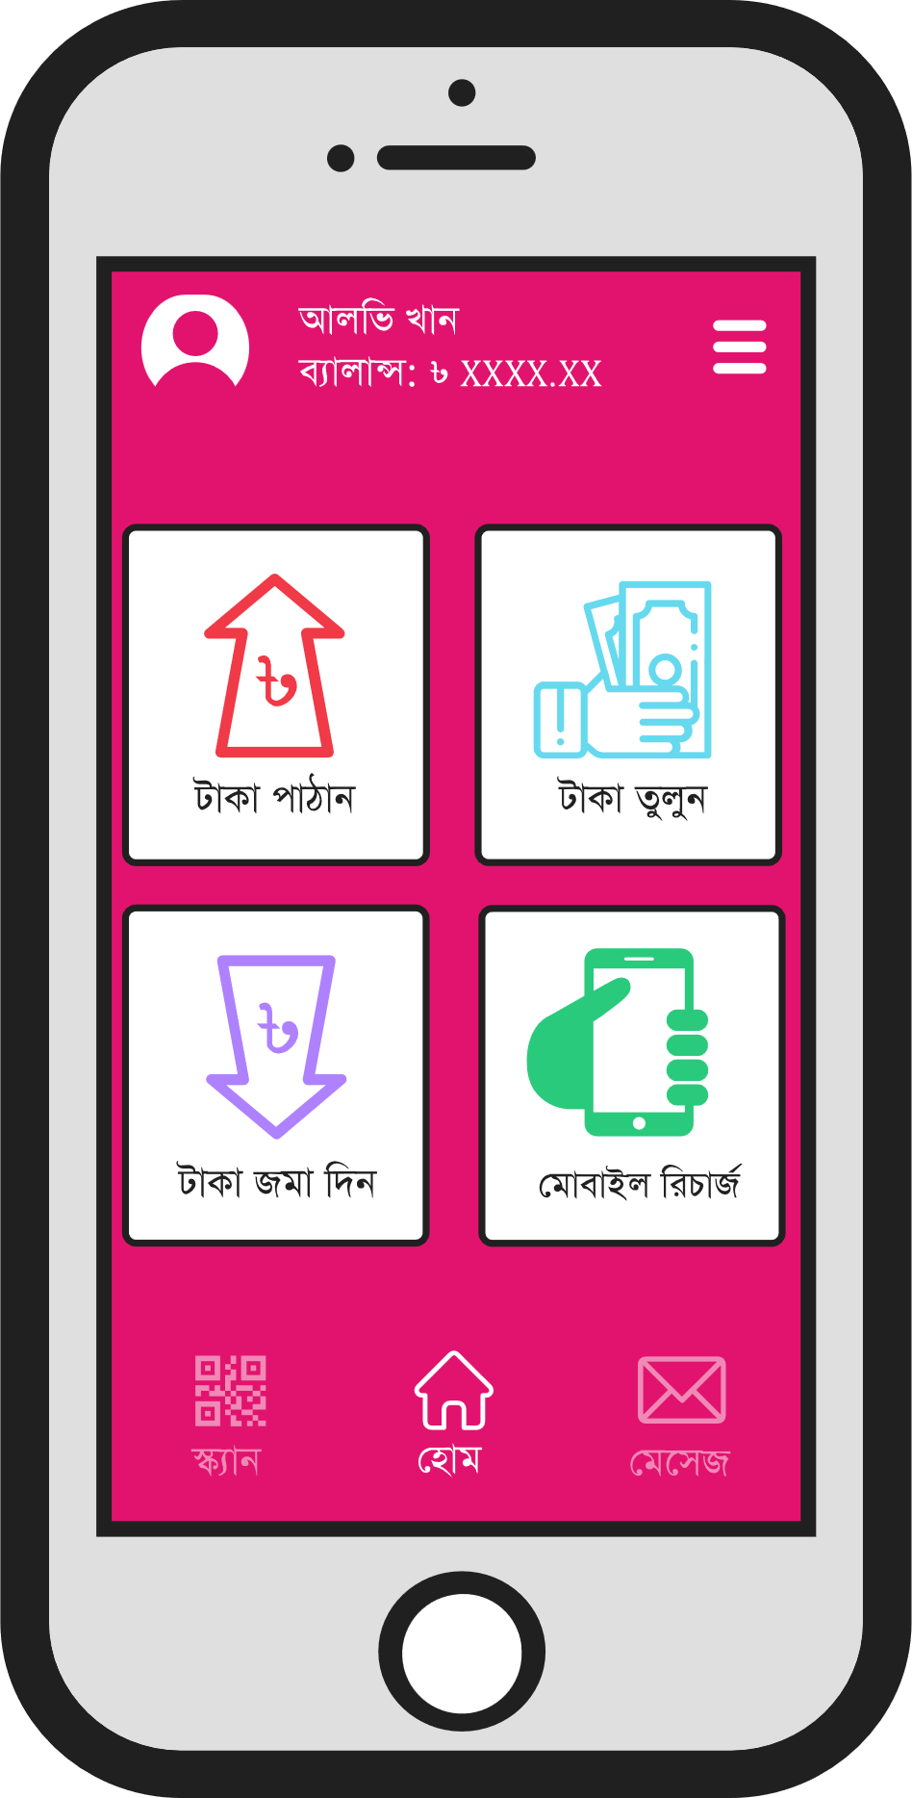

**Proposed UI**

# Improvements

## Clutter-Free UI

The most noticeable improvement is the lack of clutter on the homepage. The original UI had a huge amount of information directly on the homepage.

bKash is primarily used by a user group that is likely to have problems using a smart device. Making the UI simple for them to use is thus essential. The huge amount of information was confusing, even for those of us who are comfortable using a smart device. The main features of the application were pushed up to the top and the majority of the screen was covered by buttons for non-essential features.

In the improved UI, only the main features are provided as huge buttons. This makes it extremely unlikely that anyone who is not used to using a smart device will make a mistake. The extra features are hidden behind a menu bar on the top right.

The banner advertisement in the middle of the screen has also been removed. This is distracting and unnecessary. bKash has other sources of income and does not need revenue from advertisements. The advertisements they show are for offers within the app, and thus not even a potential source of revenue. If advertisements must be shown, they should be in a corner and not in the middle of other features.

Note that the user interface in the original bKash application used to be exactly as described for this point. It was changed.

## Text

In the original UI, even in the Bengali interface, a portion of the text was in English. This would obviously make it more difficult for any users who are unable to read English. Unfortunately, this is actually a huge problem, since the majority of bKash’s user base is unlikely to be able to read English.

In the improved UI, it is ensured that all text is in Bengali. Additionally, the wording has been changed in places. For example, the ‘ক্যাশ আউট’ button has been changed to ‘টাকা তুলুন’. The original wording would be confusing to new users, since it requires familiarity with bKash. The new wording should make it clear to anyone what the purpose of a particular button is.

## QR Code Scan Button

The position of the QR Code Scan button has been changed. The QR Code Scan feature is undoubtedly one of the best features of the application, which is why it is not being hidden. However, anyone who is used to using smart devices would most likely expect the central button to be the ‘Home’ button. They may even press it on muscle memory. As such, the ‘Home’ button has been made the central button and the QR Code Scan button has been shifted to the left.

## Iconography

The icons used for each of the buttons are arguably somewhat confusing. Alternative suggestions are provided in the improved UI. However, this is more of an opinion than a strong criticism of the original interface.

## Hidden Balance

In the original interface, the user’s balance is hidden behind a small bar that needs to be tapped to reveal the user’s balance. This feature does not provide any additional security, and was most likely included to provide some privacy.

Seeing as though this application is built specifically so that users may complete transactions from wherever they are without having to actually go to a bKash counter, the hidden balance feature causes irritation more than anything else. As such, it has been removed in the improved UI and the balance is directly shown.

This point is debatable.

## Sidebar Icon

The icon used at the top right, which reveals the sidebar, is bKash’s logo. This was a terrible decision overall, since the icon gives absolutely no hints about what the button actually does. It has been replaced by a simple hamburger icon, which can almost universally be recognized to indicate that a sidebar will be opened.

## Text-to-Speech

The final criticism of the original UI is the lack of Text-to-Speech. The original version of the bKash application included a Text-to-Speech feature. The application would read out the text for whatever button the user pressed. This feature was extremely useful, especially since a portion of bKash’s user base is illiterate. The removal of this feature is a huge step backwards. The improved UI presumably has this feature, although it cannot be shown in an image.